**RAJALAKSHMI ENGINEERING COLLEGE**

**RAJALAKSHMI NAGAR, THANDALAM – 602 105**



|  |
| --- |
| **CS23A34**  **USER INTERFACE AND DESIGN LAB** |
| **Laboratory Observation Notebook** |

**Name :** VARSHA H

**Year/Branch/Section :** II/CSE/F

**Register**

**No. :** 230701371

# Semester : IV Academic Year: 2024-25

**Ex. No.: 7.a**

**Register No.: 230701371**   **Name: VARSHA H**

**Develop low-fidelity paper prototypes for a banking app and convert them into digital wireframes using Pencil Project**

**AIM:**

The aim is to develop low-fidelity paper prototypes for a banking app and convert them into digital wireframes with Pencil Project.

**PROCEDURE:**

**Tool Link:** [**https://pencil.evolus.vn/**](https://pencil.evolus.vn/)

**Step 1: Create Low-Fidelity Paper Prototypes**

1. **Define the Purpose and Features**:
   1. Identify the core features of the banking app (e.g., login, account balance, transfers, bill payments).
2. **Sketch Basic Layouts**:
   1. Use plain paper and pencils to sketch basic screens.

○ Focus on primary elements like buttons, menus, and forms.

1. **Iterate and Refine**:
   1. Get feedback from users or stakeholders.

○ Iterate on your sketches to improve clarity and functionality.

**Step 2: Convert Paper Prototypes to Digital Wireframes Using Pencil Project**

1. **Install Pencil Project**:
   1. Download and install Pencil Project from the official website.
2. **Create a New Document**:
   1. Open Pencil Project and create a new document.
3. **Add Screens**:
   1. Click on the "Add Page" button to create different screens (e.g., Login, Dashboard, Transfer).
4. **Use Stencils and Shapes**:
   1. Use the built-in stencils and shapes to create UI elements.

○ Drag and drop elements like buttons, text fields, and icons onto your canvas.

1. **Organize and Align**:
   1. Arrange and align the elements to match your paper prototype.

○ Ensure that the design is user-friendly and intuitive.

1. **Link Screens**:
   1. Use connectors to link different screens together.

○ Create navigation flows to show how users will interact with the app. 7.

**Add Annotations**:

○ Include annotations to explain the functionality of different elements.

8. **Export Your Wireframes**:

○ Once satisfied with your digital wireframes, export them in your preferred format (e.g., PNG, PDF).

**OUTPUT:**

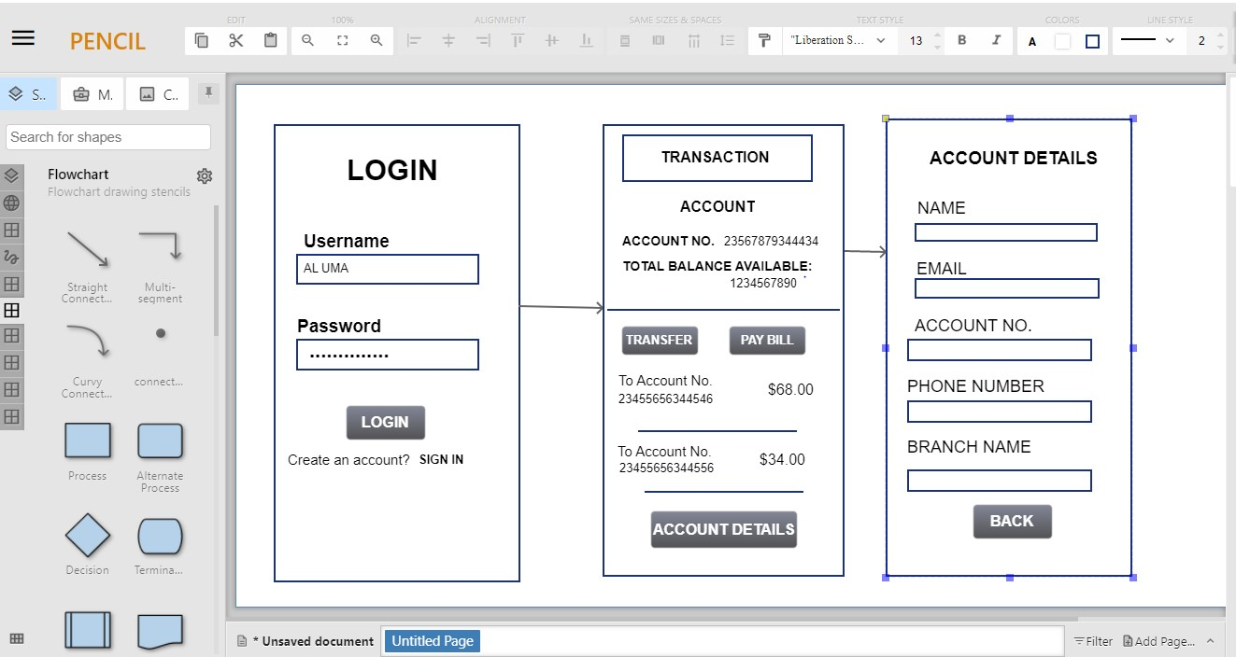

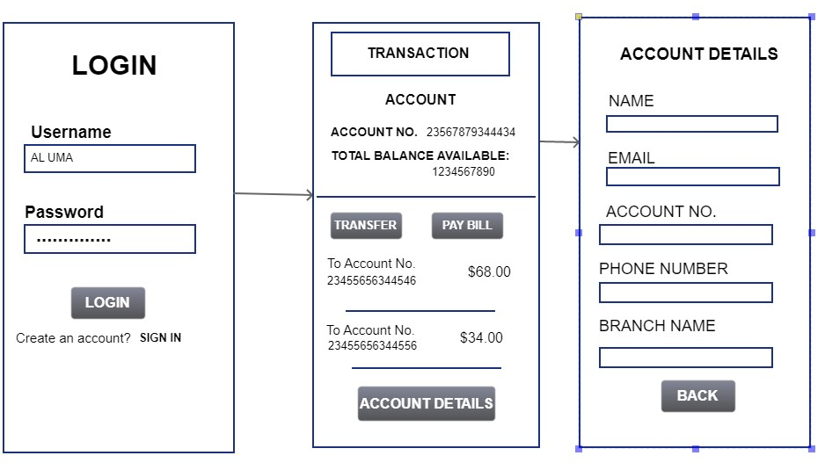

**RESULT:**

Hence we have developed low-fidelity paper prototypes for a banking app and converted them into digital wireframes with Pencil Project.